1. **Experiment:** BLI measurement of cytokine-receptor binding affinity
2. **Time:** 2025.05.26-2025.05.31
3. **Member:** Xudong Tang, Yang Jin, Binxuan Zhang, Kaiqing Zhang, Xuantong Liu
4. **Principle:** Bio-Layer Interferometry (BLI) is a label-free detection technology that converts optical interference signals generated on the surface of BLI biosensors into real-time response signals for detection. Its fundamental principle is wave interference. The biosensor consists of a glass optical fiber layer and an optical layer. At the interface between the optical fiber layer and the optical layer, the first reflected light is generated, while the second reflected light is produced at the interface between the optical layer and the external solution. The superposition of these two waves forms an interference spectrum curve. When the bait binds to the ligand immobilized on the sensor surface, the thickness of the optical layer increases, causing the path length of the second reflected light to become longer than before. This results in a change in the interference spectrum curve, shifting it to the right. When the bait and ligand dissociate, the bait detaches from the biosensor surface into the solution, causing the interference spectrum curve to shift to the left. A plot of the shift distance of the interference spectrum curve against the reaction time is called a sensorgram. Based on various binding models, the association constant (Ka or Kon), dissociation constant (Kd or Koff), and affinity (KD) can be fitted. Using the sensorgram, fitted curves, and affinity kinetic parameters, the affinity of designed IL-2R agonists for IL-2Rβ and IL-2Rγ can be evaluated and ranked.

Biosensors offer diverse methods for immobilizing bait molecules, including amine coupling, biotin/streptavidin, antibody/anti-Fc, His-tag/Ni-NTA, GST/anti-GST, or FLAG/anti-FLAG interactions, to form a biomolecular layer on the tip of the fiber optic biosensor. In this experiment, due to the widespread use, high affinity, and effectiveness of SA sensors, we selected SA sensors to immobilize the bait IL-2Rβ or IL-2Rγ for analyzing the affinity of IL-2R agonists. SA sensors utilize the interaction between streptavidin and biotin. Therefore, we purchased IL-2Rβ and IL-2Rγ with a His-tag (for purification) from Novoprotein, with the sequence number C33A. In subsequent operations, these were used as bait and pre-biotinylated.

1. **Materials:** SA Sensors, Greiner 96-well Black Plate, PBST Buffer (0.02% Tween 20), 1.5 mL EP Tubes, 15 mL Centrifuge Tube, Empty Sensor Tray, Octet® RED96 BLI instrument, IL-2Rβ, IL-2Rγ, IL-2 mimics
2. **Method:**
3. Preparation: The IL-2 receptor was purified and fused with the target sequence. N-terminally biotinylated target peptides of IL-2Rβ and IL-2Rγ, containing a short linker (GGS) and a biotin-Ahx modification, were immobilized on streptavidin-coated biosensors (SA ForteBio) at a concentration of 50–100 nM in binding buffer. The Data Acquisition software of the Octet system is launched. After approximately 1 minute, the instrument initialization is completed and the Ready status is displayed.
4. Pre-experiment: Determine the bait concentration. The bait concentration range is between 5 and 50 µg/mL. Use three different bait concentrations to determine the optimal concentration: 50, 100, and 200 µg/mL. Choose the bait concentration that yields a 1 nm binding response signal.
5. Next, determine the analyte concentration gradient. Perform a broad-range screening (10 nM, 100 nM, 1000 nM) to roughly estimate the KD range. Based on this, design the formal experiment gradient. The high concentration in the formal experiment must be ≥10 × KD, with the highest concentration set at 10-20 times KD. A 2-3-fold dilution series of 5-7 concentration gradients is used as the formal experiment concentration gradient.
6. To avoid non-specific binding, perform two additional control experiments: immobilized bait detection of a blank group, and immobilized blank group bait detection of the analyte. The blank group consists of a buffer without bait or analyte. Through these pre-experiments, non-specific binding can be avoided and the KD can be obtained.
7. Sensor pre-humidification: Pre-wet plates were placed in a blue chassis (corner A1 of the sample plate needed to be snapped into the snap hole of the blue tray), and 200 μL of analytical buffer, such as PBST buffer, was added to the well where the sensor was placed. The sensor was placed on the green disk, and then the green disk was snapped onto the blue disk. The sensor needed to be pre-wetted for over 10 minutes.
8. Methods Edit: Within the Experiment Wizard software, the "New Kinetics Experiment-Basic Kinetics" option was selected. Following this, the protocol setup interface was accessed. The Basic Kinetics Experiment window was maximized, and the following five steps were sequentially edited:
   * 1. Plate definition: In the plate definition setup, four sample columns were designated as follows: Buffer1 was assigned to the baseline1 step, Load to the loading step, Buffer2 to both the baseline2 and dissociation steps, and Sample to the association step. The samples consisted of different test sequences at identical concentrations, with each well being loaded with 200 μg/L of the respective sample. Following the completion of parameter configuration, the experiment was initiated.
     2. Assay definition: In the assay definition, the setup steps were followed by first clicking "Add" in the window to include the required analysis steps and set the duration for each one. The following steps were added: Baseline (60 s), Loading (120 s), Baseline2 (120 s), Association (180 s), and Dissociation (180 s), after which "OK" was clicked to confirm the selections. If any parameter required modification, it was edited by double-clicking. Next, in the "Step Data List", the Baseline step was clicked, the arrow was moved to Baseline to indicate that the detection position for this step on the sample plate would be configured, and then the first column of samples on the sample plate was double-clicked, so that at the start of the experiment, the Baseline step would be detected using the samples in the first column (buffer). The "Assay Steps List" then displayed the first added step, showing that the Baseline analysis was performed using samples from the first column, with "No" indicating the step number, "Sample" representing the analysis location on the sample plate, and "Sensor Type" specifying the sensor selected for analysis. This process was repeated to complete the experimental setup for the entire kinetic analysis.
     3. Sensor assignment: In the sensor assignment, the sensor position was configured.
     4. Review Experiment: Clicking the buttons allowed browsing the previous or next step of the experiment respectively, enabling preview and verification of all experimental steps.
     5. Run Experiment: After the setup was completed, the "Start Experiment" button was clicked. Before the experiment was initiated, it was ensured that the samples and sensors were properly placed and the instrument door was securely closed.
9. **Result Analysis:** The related data were acquired and processed using the Data Analysis software of the Octet® system. Through this analysis, sensor grams were generated, from which kinetic parameters including KD, Kon, Koff, and steady-state fitting curves were derived. The consistency between the fitted and measured curves was evaluated. If the fitted curve showed strong agreement with the experimental curve, it indicated high quality of the fitting results. Based on these data, a comprehensive assessment of the binding affinity between the test sequences and the receptor was performed.
10. **Result:**

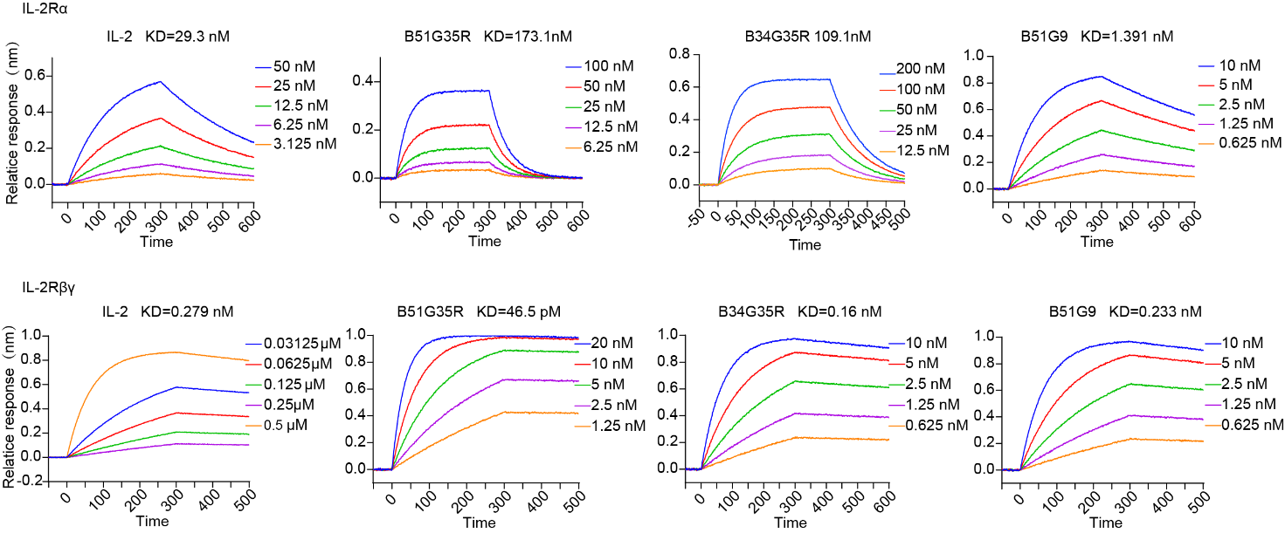

**Figure.1** BLI characterization of the binding of designed proteins to the IL-2Rα and IL-2Rβγ respectively. Twofold serial dilutions were tested for each binder and all concentration are labelled. The IL-2 mimics were loaded onto streptavidin biosensors, and incubated with designed binders in solution to measure association and dissociation.